Asian Buffet
Menu

Starter
3 x Starters selected from our Vegetarian and Non Vegetarian options

Main Course
1 x Vegetarian Main Course selection
2 x Non Vegetarian Main Course selections 1 x Dal selection
1 x Raita selection 1 x Rice selection
2 x Naan or Paratha selections Indian Salads, Popodoms & Chutneys

Dessert
2 x Dessert selections

From £38.00 per person for a 3 Course Meal

Our Executive Chef welcomes your suggestions or requests.
All our Asian Dishes are from our Authentic Indian menu prepared by our highly skilled Asian Chefs.
It will be our pleasure to cater for your particular favourite dish if not already included on our Banqueting Selector.

All Menus can be tailored to suite your Budget and preference for your event.
Guests with special Dietary requirements can be catered for with prior notice.

Crowne Plaza Marlow
01628496800 www.cpmarlow.co.uk events@cpmarlow.co.uk

Banqueting Menu Selector

Starters & Canapés

Non Vegetarian Selection
Chicken Dishes £6.95 Per Dish
Lamb Dishes £7.25 Per Dish

Lazeez Chicken Tikka
Tender cubes of Chicken cooked in a Tandoor with Spices

Achari Murgh Tikka©
Chicken cooked in Tandoor with Pickling Spice

Chicken Hariyali Kebab©
Chicken Tikka marinated in Yoghurt , Mint and Spinach
Malai Kebab©
Chicken marinated with Cream Cheese and char grilled in a Tandoor

Chilli Chicken
Indian Chinese style Chicken with mixed Peppers

Murg Tangry Kebab
Chicken Drumsticks marinated in whole Spice and Char Grilled in Tandori

Adraki Lamb Chops
Clove smoked Lamb Cutlets marinated with Cashews , Ginger and Yogurt

Lamb Shami Kebab©
Spring Lamb minced with Lentils, fresh Coriander, Mint, Herbs, Spices and Deep Fried

Boti Kabab
Diced Lamb marinated overnight and cooked to perfection

Fish Selection £7.25 Per Dish

Fish Amritsari©
Punjabi style Fried Fish
Achari Prawn©
Prawns marinated in Indian spices & Pickle and cooked in the Tandoor
Malvani Tilapia©
Diced Fish fillet coated in Semolina and spices and shallow fried
Salmon Tikka©
Diced Salmon marinated in Tandoori marinade and cooked in oven

Vegetarian Selection £6.00 Per Dish

Paneer Shashlik
Cottage Cheese interlayered with Bell Peppers and Onions, marinated and cooked

Paneer Tikka©
Dices of Cottage Cheese marinated overnight and cooked
Paneer Pakora
Gram Flour batter fried Cottage Cheese

Chilli Paneer ©
Indo-Chinese style Paneer with mixed Peppers
Subj Ka Shammi
Ground minced Vegetable Cutlet

Spring Rolls©
Spring Rolls filled with wok fried Oriental Vegetables
Samosa©
Potato and Green Pea stuffed Pastry

Aloo Papdi Chaat ©
Boiled Potatoes and flour Crisps with Tamarind, Mint and Yogurt
Hara Bara Kebab ©
Spinach Paneer Potato patties

Aloo Mint Tikki ©
Deep fried Potatoes cakes with Mint Chutney
Onion Bhaji
All Time Favourite

Mix Pakora©
Seasonal Vegetables spiced and coated with Gram Flour and fried

Veg. Manchurian©
Indo Chinese style Vegatable Dumplings in Soya and Sweet Chilli
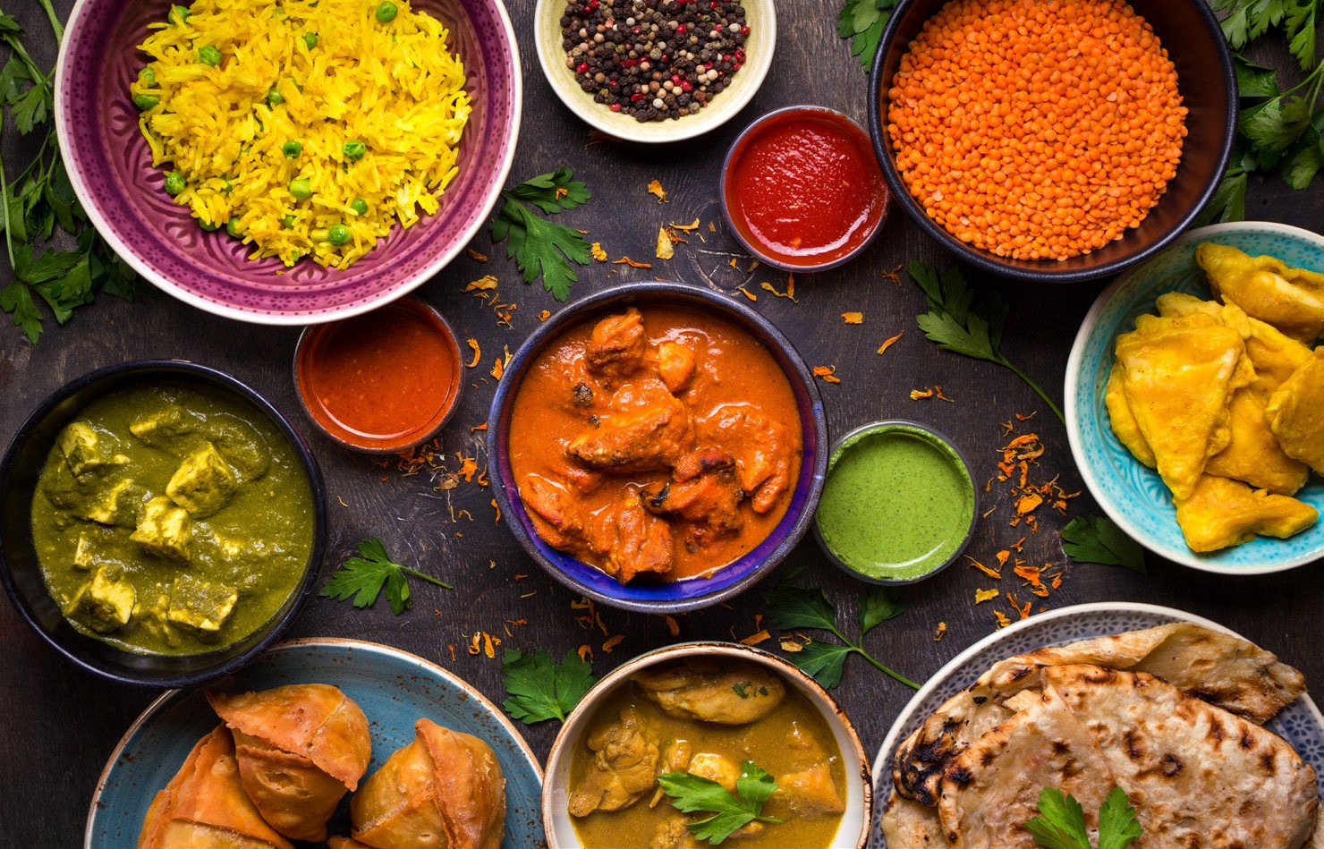

Main Course

Non Vegatarian Selection
Chicken Dishes £13.75 Per Dish
Lamb Dishes £16.95 Per Dish

Lahori Chicken Curry
Chefs special home style Chicken Curry

Butter Chicken
Classic rich Curry of Chicken marinated in Yogurt, Cream and Spices

Bhuna Chicken
Chefs special, Char Grilled Chicken cooked in dry spices flavoured with Indian Spices
Leaves

Chicken Hydrabadi Korma
Chicken Cubes cooked with Coconut, Onion and Yoghurt Gravy

Chicken Jalfrezi
Diced Chicken Breast cooked with mixed Peppers, Onion and Spices

Kadai Chicken
Char Grilled Chicken Tikka cooked in Kadai Gravy

Saag Chicken
Chicken cubes cooked in creamy Spinach sauce

Lamb Rogan Josh
Lamb cooked with Onions, Tomato, Spices, Ginger, Garlic and fresh Coriander

Saag Gosht
Diced Lamb cooked in a creamy Spinach Sauce

Lamb Vindaloo
Lamb Vindaloo is spicy hot dish from Goa, Made with whole Spices, Vinegar and lots of Hot Red Chilli

Patiala Gosht
Speciality of Patiala in Punjab

Keema Matter
Minced Lamb cooked with fresh Green Peas

Bhuna Lamb
Diced Lamb cooked with Onions and Pepper

Fish Selection £16.95 Per Dish

Goa Fish Curry
Tilapia fillet in Coconut, Tamarind and Spices

Macher Jhol
Bengal favourite Fish Curry with New Potatoes

Prawn Moilee
A mild Curry with Coconut and Onions, Tempered with
Mustard Seeds and Curry Leaves

Biryani Selection
Lamb Biryani £15.00
Chicken Biryani £14.00
Vegetarian Biryani £13.00

Vegetarian Selection £12.00 Per Dish
Paneer Lababdaar
Diced Cottage Cheese cooked in creamy Onion Tomato Gravy

Matter Paneer
Fresh Peas and Cottage Cheese cooked with Tomatoes and Ginger

Palak Paneer
Diced Cottage Cheese cooked in creamy Spinach Sauce

Paneer Matter Mushroom
Home style Cottage Cheese, Peas and Mushroom Curry

Palak Mushroom
Mushroom cooked in Spinach

Aloo Matter
Home style, Potatoes and Green Pea Curry

Baingan Bhartha
Oven cooked minced Brinjal mixed with Onion spiced Masala

Aloo Achari Baingan
Pickled baby Eggplant cooked with Potatoes

Vegetable Jalfrezi
Panache Vegetables cooked in Kadai Masala

Adraki Aloo Gobi
New Potatoes and Cauliflower wok fried with Ginger and Tomatoes

Achari Matter Mushroom
Pickled Wild Mushroom cooked with Green Peas

Kadhi Pakora
Gram flour Dumplings cooked in Yogurt

Veg Korma
All seasonal Vegetables cooked with Coconut, Onion and Yogurt Gravy

Aloo Beans
French Beans and Baby Potatoes cooked with Onion, Tomatoes and Spices

Dal Makhani
Chef Special Black Lentils, cooked with Tomato and Cream

Dal Panchmel
5 types of Lentils, cooked with Spices and flavoured with Ginger and Coriander

Dal Tadka
Yellow Lentils tempered with Red Chillies, Cumin and Coriander

Pindi Chole
Chickpeas cooked with dried Spices, Onions and Tomatoes

Rajmah Kashmiri
Red Kidney Beans cooked with Onions, Ginger and Tomatoes

Raita Selection

Onion & Cucumber Raita | £1.75
Cucumber Raita | £1.75
Boondi Raita | £1.75
Potato & Onion Raita | £1.75
Mixed Raita | £1.75
Rice Selection
Steamed Rice | £2.05
Lemon Rice | £2.05
Jeera Pilau | £2.05
Green Pea Pilau | £2.05
Vegetable Pilau | £2.25

Bread Selection
Plain Naan £2.05
Butter Naan £2.05
Parantha (Plain) £1.75
Parantha (Cottage Cheese) £2.05

Dessert
£5.50 Per Dish

Rice Kheer
Rice cooked in Milk, Nuts and Raisin flavoured with Cardamom
Gulab Jamun
Sweet Brown Dumplings, dipped in Sugar Syrup
Gajar Halwa
Grated Carrots cooked in reduced Milk

Fruit Cream Fruit Custard
Fresh Fruit Platter

Crowne Plaza Marlow
01628496800 www.cpmarlow.co.uk events@cpmarlow.co.uk

